private void btnRun_Click(object sender, EventArgs e)

{

double Salary,Tax,Net_Salary;

string Name;

Salary = Convert.ToDouble(tbxSalary.Text);

Name = tbxName.Text;

Tax = CalTax(Salary);

Net_Salary = CalNet_Salary(Salary, Tax);

lblTax.Text = Convert.ToString(Tax);

lblNet_Salary.Text = Convert.ToString(Net_Salary);

}

-----------------------------------------------------------------------------------------

private double CalTax(double Salary)

{

double Tax;

if (Salary < 5000)

Tax = 0;

else if (Salary <= 10000)

Tax = Salary * 0.03;

else if (Salary > 10000)

Tax = Salary * 0.05;

else

Tax = 0;

return Tax;

}

-----------------------------------------------------------------------------------------

private double CalNet_Salary(double Salary, double Tax)

{

double tempTSalary = Salary - Tax;

return tempTSalary;

}

-----------------------------------------------------------------------------------------

ตัวอย่างการ Run โปรแกรม

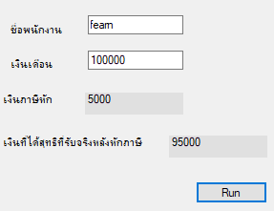

โปรแกรมเดิม

private void btnRun_Click(object sender, EventArgs e)

{

double Salary,Tax,Net_Salary;

string Name;

Salary = Convert.ToDouble(tbxSalary.Text);

Name = tbxName.Text;

if (Salary < 5000)

{

Tax = 0;

}

else if (Salary <= 10000)

{

Tax = Salary * 0.03;

}

else if (Salary > 10000)

{

Tax = Salary * 0.05;

}

else

{

Tax = 0;

}

Net_Salary = Salary - Tax;

lblTax.Text = Convert.ToString(Tax);

lblNet_Salary.Text = Convert.ToString(Net_Salary);